SOP
Student Registration on the
Assam State Higher Education Student Portal https://assamshesp.samarth.edu.in/index.php/site/login (For students who are not yet registered)
Student Portal • User Registration & Login

FOR STUDENT USERS
Open Portal | Register | Verify OTP | Set Password | Login
Purpose: To provide a clear, visual, step-by-step procedure for first-time students to create an account on the Assam State Higher Education Student Portal.

COMPILED BY
DIRECTORATE OF HIGHER EDUCATION, ASSAM
& SAMARTH e-GOV

- Before You Start
- Keep your correct Enrolment number ready.
- Make sure the mobile number and email address registered with your institution are accessible for OTP verification.
- Use the Assam State Higher Education Student Portal registration/login https://assamshesp.samarth.edu.in/index.php/site/login page.
- Do not share your OTP or password with anyone.

Step-by-Step Procedure
The following steps are based on the complete screen recording provided for the Assam State Higher Education Student Portal registration process.

Open the Student Portal
Open the Assam State Higher Education Student Portal login page https://assamshesp.samarth.edu.in/index.php/site/login. For a first-time user, select New User Registration/Register.

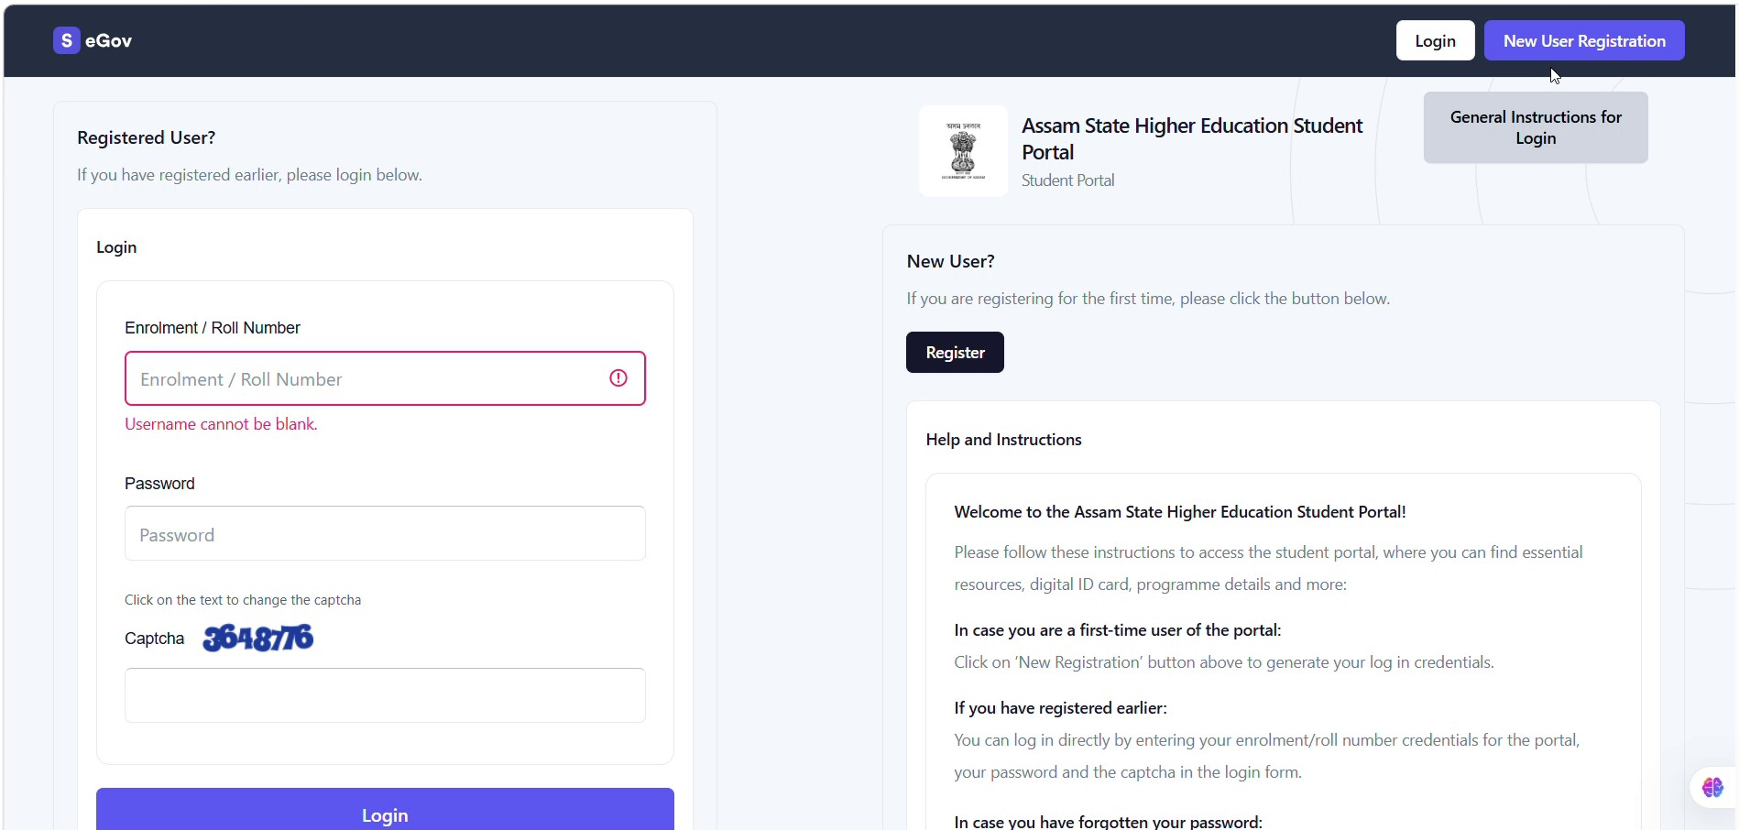


Students can click here for new registration

Figure 1. Login page. Select “New User Registration” to begin.

Enter the Registration Details
Enter your Enrolment Number and the Captcha displayed on the registration page.

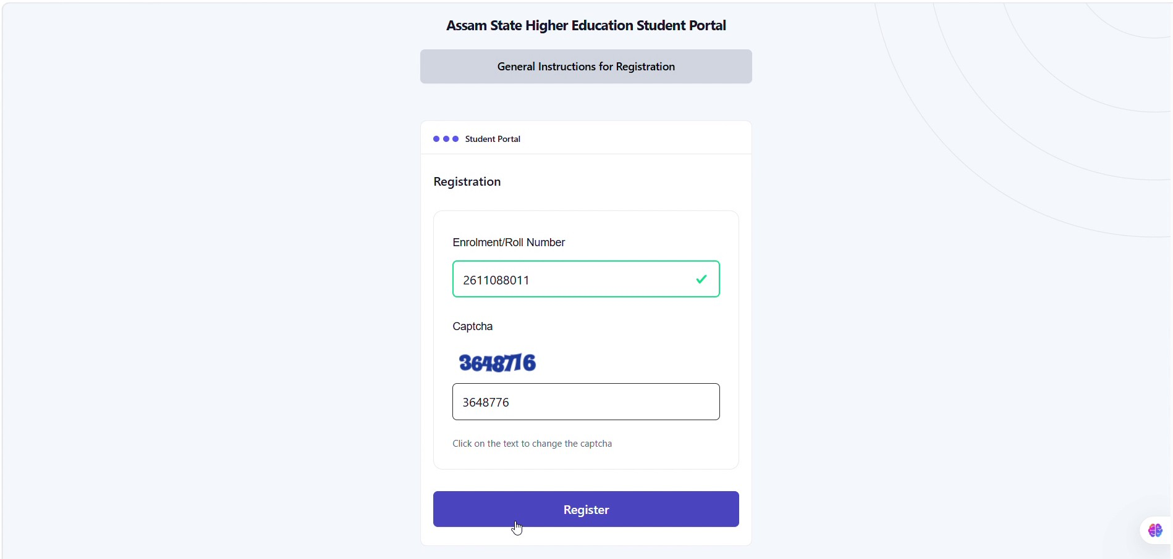



Insert enrolment no. here

Enter Captcha

Click Register

Figure 2. Registration page.

Check the OTP Notification
After registration is submitted, the portal confirms that the mail has been sent successfully and proceeds to OTP verification.

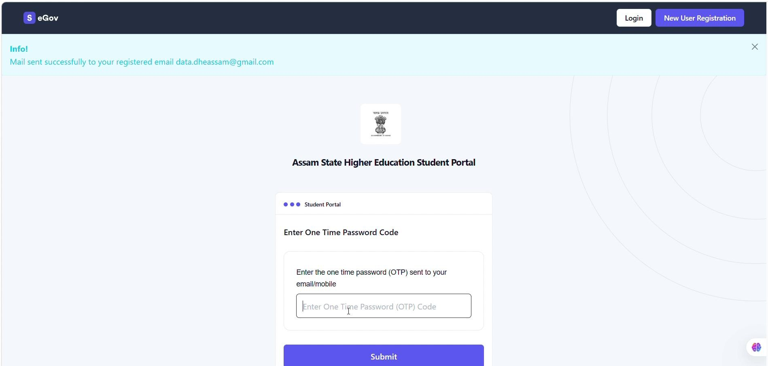

Enter the OTP sent to registered mail

Figure 3. OTP notification.

Set Your Password
After OTP verification, enter a password and confirm it in the “Confirm Password” field. After entering and confirming the password, click “Reset Password”.

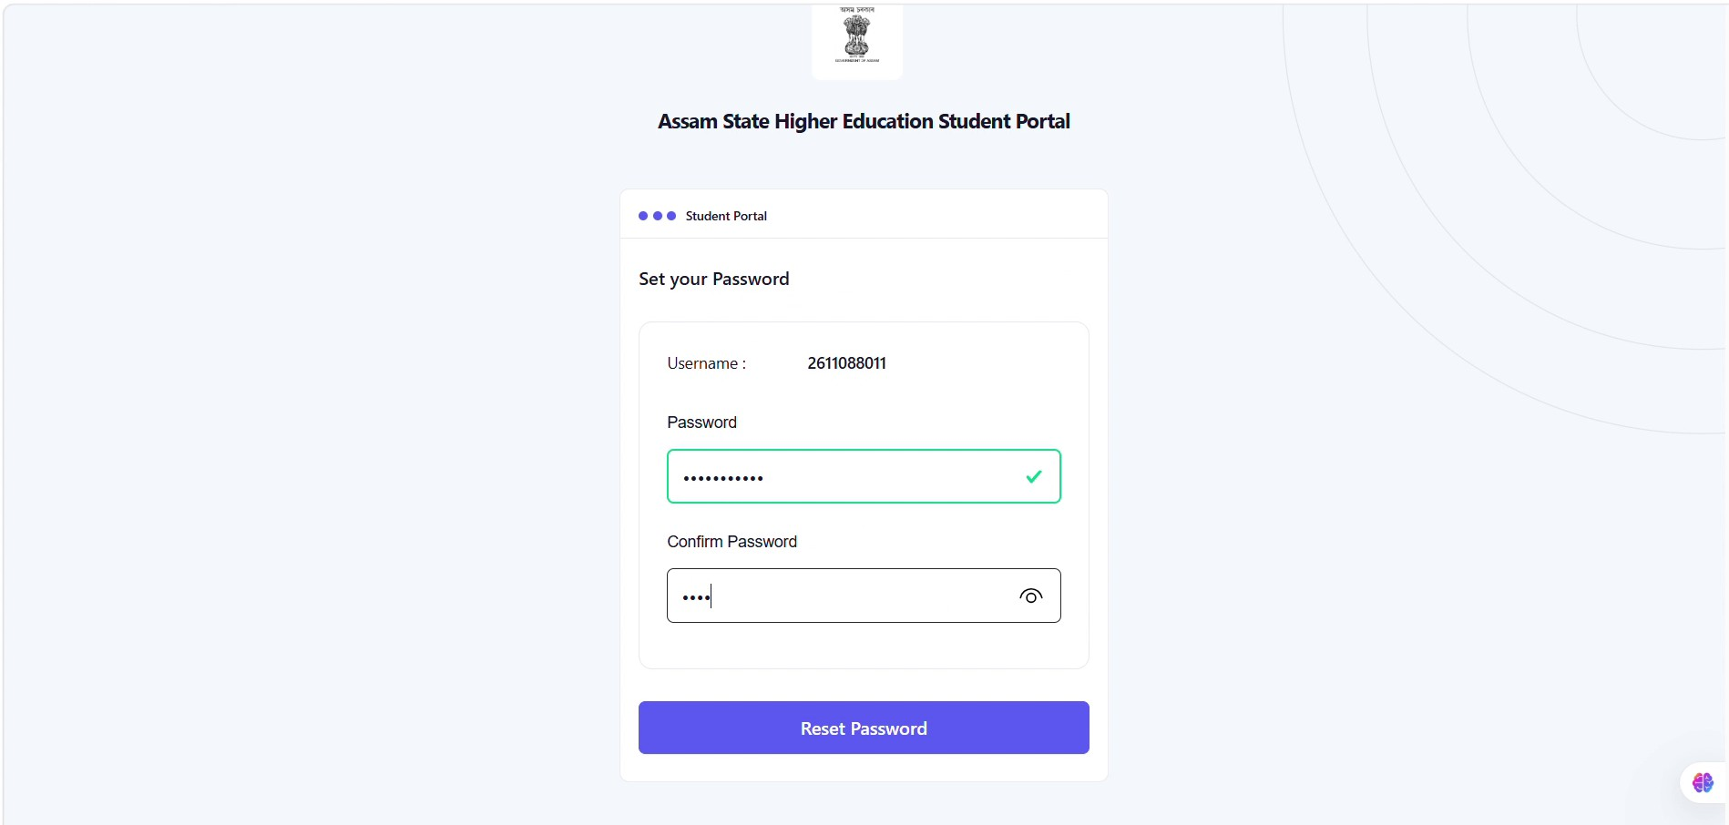



Enter the password and confirm

Click on Reset Password

Figure 4. Password creation.

Registration Successful
A success message confirms that registration has been completed and that you can now log in.
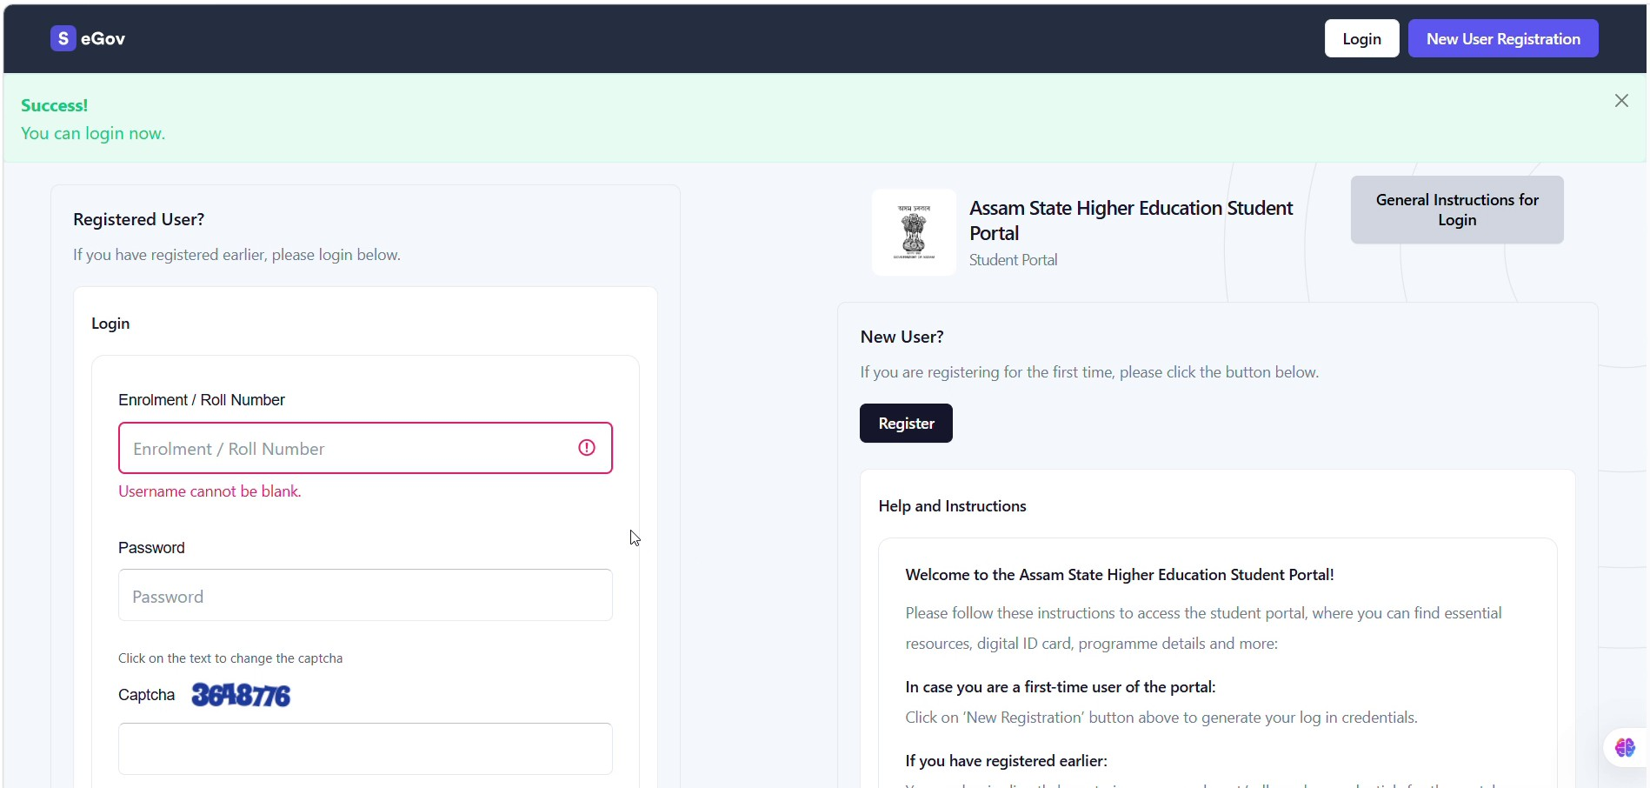
Figure 4. Registration successful.

Log In to the Student Portal
Return to the login page. Enter your Enrolment / Roll Number, password and Captcha, then click “Login”.
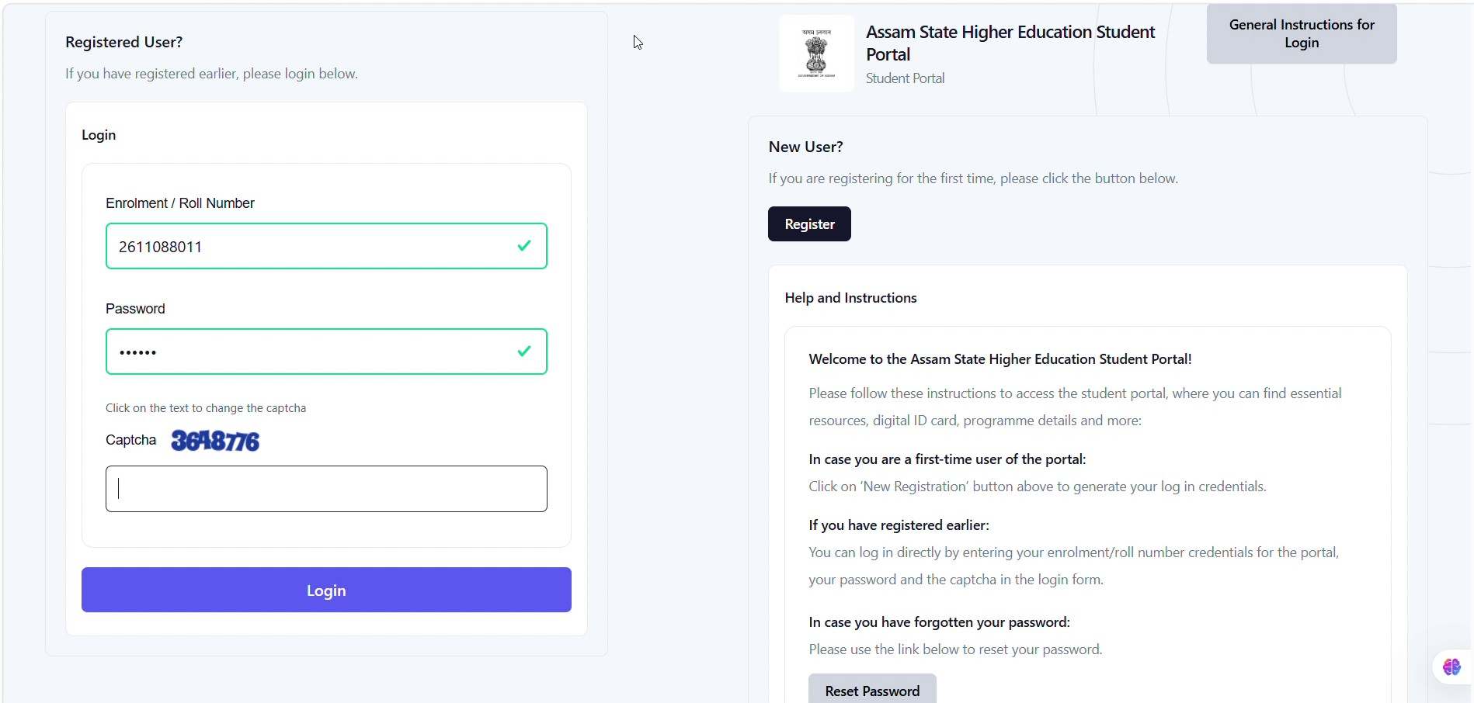
Figure5. Student login page.

Registration Flow at a Glance

2.1 | Open the Student Portal and select New User Registration.
2.2 | Enter Enrolment Number and Captcha and Click Register.
2.3 | Check the registered email for the OTP. Enter OTP and click Submit.
2.4 | Set and confirm the password. Click Reset Password.
2.5 | Registration successful — return to the login page.
2.6 | Log in using Enrolment / Roll Number, Password and Captcha.

STANDARD OPERATING PROCEDURE

Student Application for Fee Waiver 2026
Assam State Higher Education Student Portal

FOR STUDENT USERS
Open Scholarship | Select Fee Waiver | Enter Income | Upload Certificate | Submit
Purpose: To provide a visual, step-by-step procedure for eligible students to apply for Fee Waiver 2026 through the Assam State Higher Education Student Portal.

Before You Start
- Ensure that you are registered in the Assam Samarth Students Portal https://assamshesp.samarth.edu.in/index.php/site/login
- Keep the required family income details and the applicable income certificate/document ready for upload.
- Ensure that the uploaded document is clear and legible.
- Do not share your login password or other confidential credentials with anyone.

Step-by-Step Application Procedure
The following steps are based on the complete screen recording provided for the Fee-Waiver application process.

Log In to the Student Portal

Enter your Enrolment / Roll Number, password and Captcha, then click “Login”.
Figure 1. Student login page.

Home Screen After Login
After successful login, the student is taken to the Dashboard/Home screen. From the left-side Student Services menu, select “Scholarship” to view available scholarship opportunities.

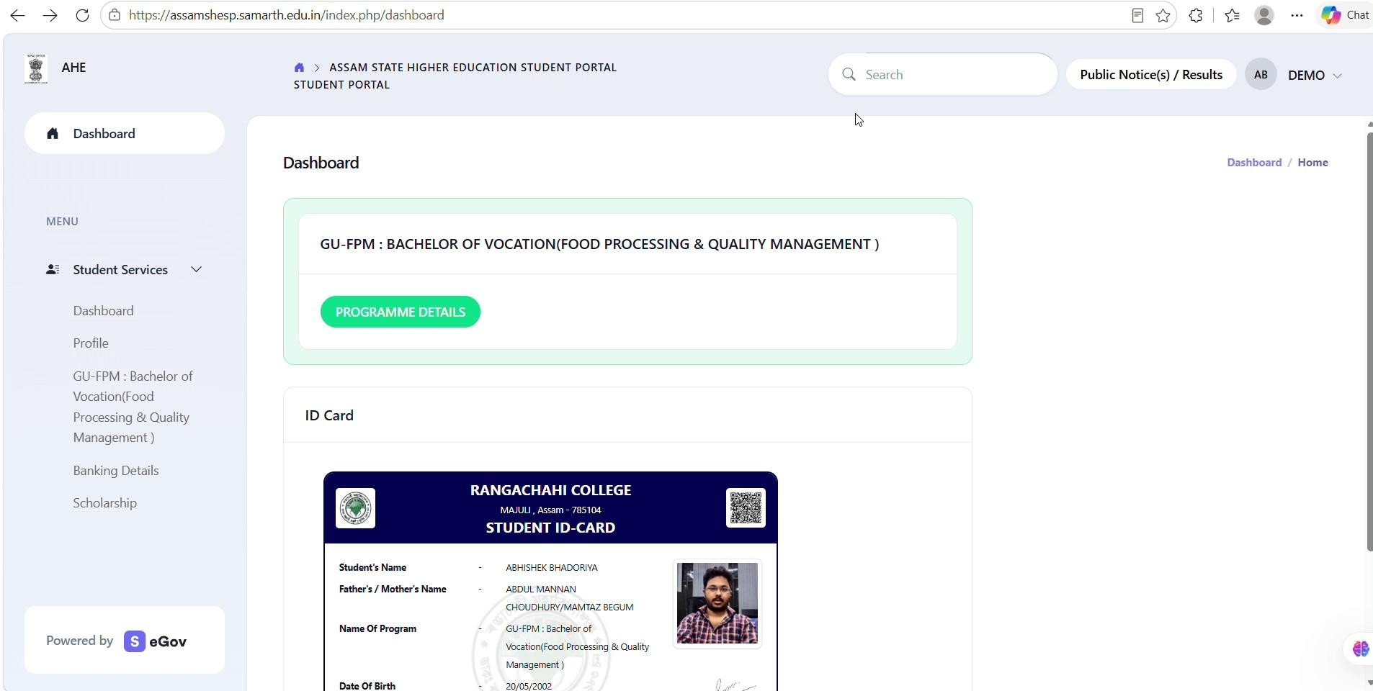



Click on Scholarship

Figure 2. Student dashboard/home screen after login.

Open Scholarship Opportunities
From the Dashboard/Home screen, open the “Scholarship” section under the Student Services menu. In the Scholarship Opportunities list, locate “FEE WAIVER 2026” for the relevant academic year and click the corresponding “Apply” button.

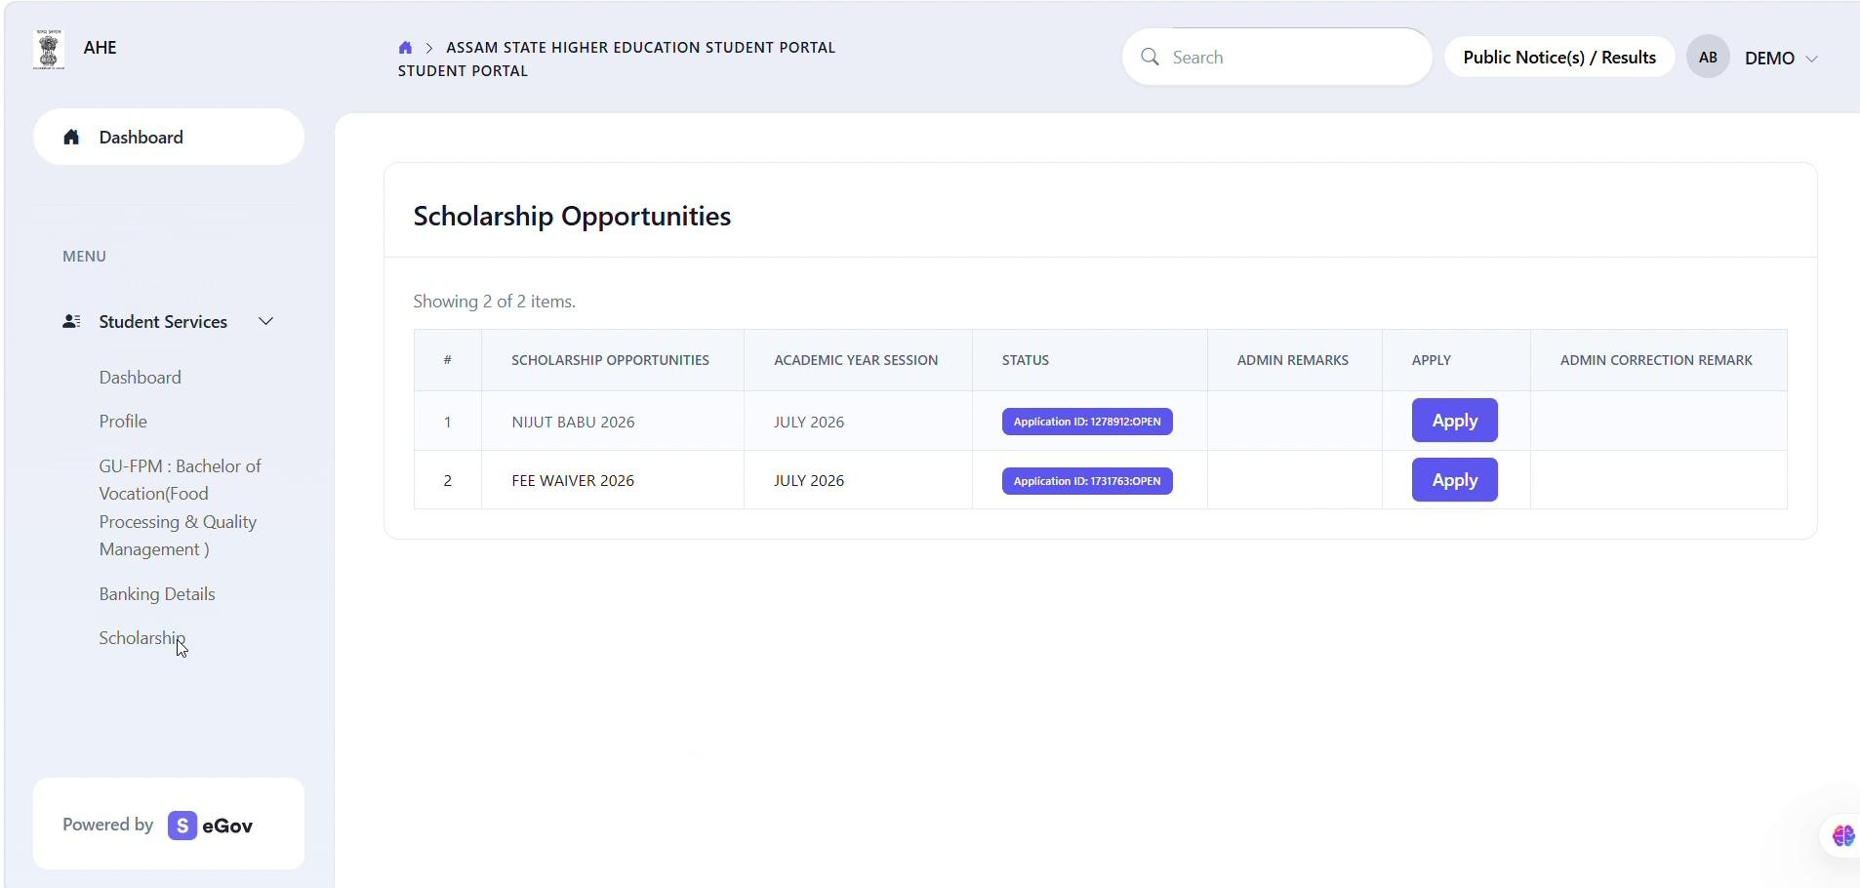
Click on Apply

Figure 3. Scholarship Opportunities page.

Enter Family Income Details
The Fee Waiver Details & Uploads page opens. Enter the student’s Family Income in the prescribed field. Read the declarations carefully.

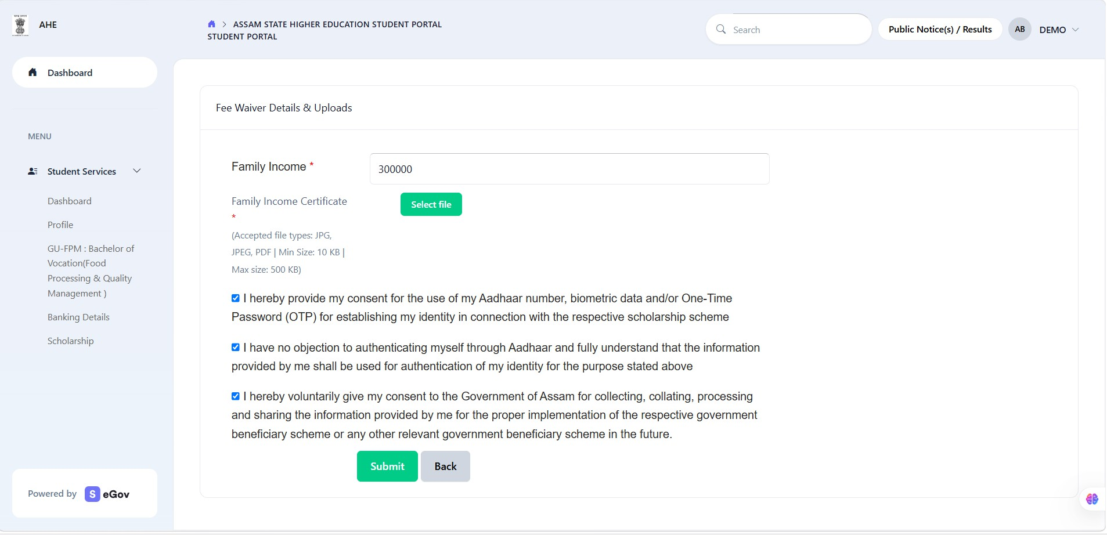



Insert Family income

Tick on the Check boxes

Click on Submit

Figure 5. Fee Waiver Details & Uploads page.

Fee-Waiver Application Flow at a Glance

2.1 | Log in to the Assam State Higher Education Student Portal.
2.2 | In the Home Screen Click on Scholarship.
2.3 | Locate FEE WAIVER 2026 and click Apply.
2.4 | Enter the Family Income. Upload the applicable Family Income Certificate. Read and accept the declaration. Verify the details and click Submit.
Important: A student can apply through SAMARTH only after being onboarded onto the Fee-Waiver Application Portal. Student should contact their respective Institutions if Fee-waiver application is not active in their login.

